 | 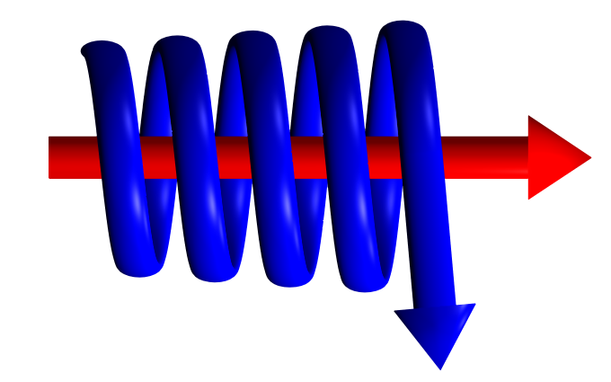 | GAS SEPARATOR & FILTER ENQUIRY FORM.

In order for Kelburn Engineering Limited to supply a fully detailed quotation, please supply as much information as possible, clearly stating the units of measurement. Items marked with “*” must be completed for a fully detailed quotation.

Customer Name: (*)
Customer Address: (*)
Contact Name: (*)
Contact Position:
Contact Telephone No:
Contact Fax No:
Contact Email Address: (*)
Gas Mass or Volume Flow: (*)
Molecular Weight of Gas:
Operating Pressure: (*)
Operating Temperature: (*)
Gas Density:
Compressibility Factor:
Pipeline Size/Flange Rating:
Liquid Volume:
Liquid Density:
Application / Location
Material of Construction:
Design Pressure:
Design Temperature:
NDT Requirements:
Separation Efficiency Required:
Other Information:

