 | 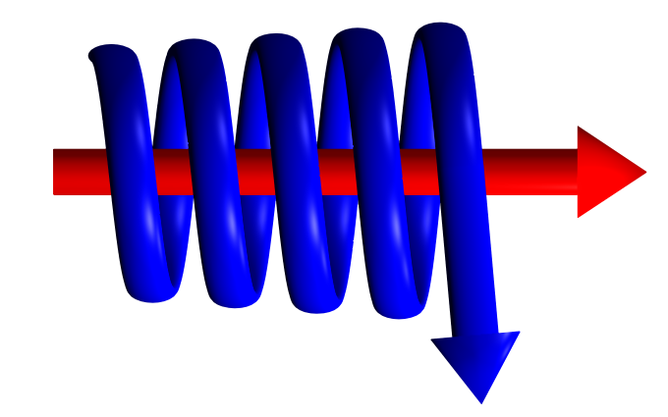 | CYCLONE AIR OR GAS SEPARATOR ENQUIRY FORM.

In order for Kelburn Engineering Limited to supply a fully detailed quotation, please supply as much information as possible, clearly stating the units of measurement. Items marked with “*” must be completed for a fully detailed quotation.

Customer Name: (*)
Customer Address: (*)
Contact Name: (*)
Contact Position:
Contact Telephone No:
Contact Fax No:
Contact Email Address: (*)
Air/Gas Mass or Volume Flow: (*)
Molecular Weight of Gas
Operating Pressure:(*)
Operating Temperature:
Pipeline Size/Flange Rating:
Material of Construction:
Design Pressure:
Design Temperature:
NDT Requirements:
Other Information:

